Purpose
This document is a How-to guide for using Javelin to read a CSV into a database table in MSSQL.

Before Starting the Flow
In the Variables Pane the user must Define:
(If this is not already open in Javelin you can bring it up by clicking the variables button in the bottom left of the Javelin Window)

filePath = the path where the scv is stored (for example: “c:\temp\myCsv.csv” )
severName = the name of the server that holds the database (eg: “JSMITH\SQLEXPRESS”)
dbName = the name of the database eg (“AdventureWorks2012”)
TableName = The name of the Table to output to in SQL, this may already exist, but does not have too.
UserName = The Username that has access to the database
Password = The password

Running the flow
The flow is composed of 3 main actions
- Start the flow and javelin moves to the FormatCreateTableStatement action and creates a SQL Create Table statement. It uses the first row of the CSV as the Columns in the table and the table is named using the string held by your variable TableName.
- Javelin then moves to the Create Table action where it creates a table using the name you defined in the variable TableName. The column titles are taken from the first row of the input csv. Each column can hold a string with a maximum length of 100 characters.
- Javelin then moves onto the AppendToTable action where it appends the CSV to the Created table.

What if the table already exists when executing in part 2?
If the table already exists, the Create Table action will throw an exception that is printed to the log: “Error executing Create Table: There is already an object named TableName in the database.”. It will progress to the AppendToTable action regardless since the CreateTable action has its ContinueOnError property set to “True”.

Screenshots that number all actions in the flow.
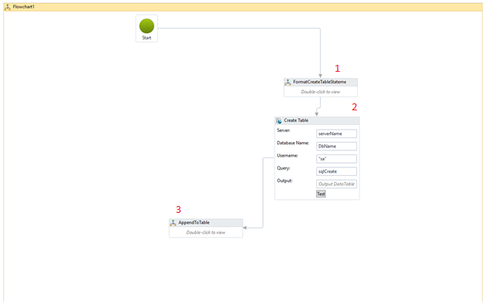
Figure 1:Screenshot of the main flow.
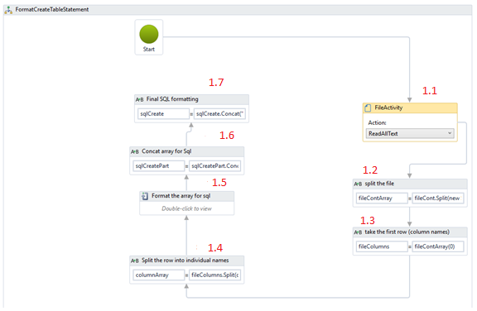
Figure 2:Screenshot of the FormatCreateTableStatement Sub Flow (Numbered 1 on Figure 1)
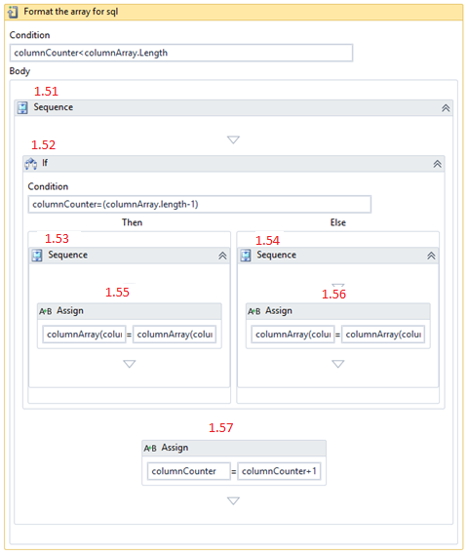
Figure 3: Screenshot of the while loop (numbered 1.5 in Figure 2).

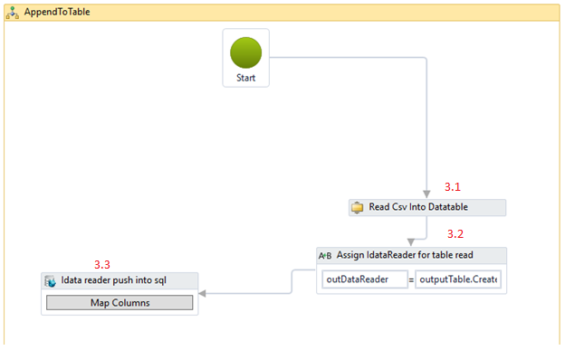Figure 4: Screenshot of the AppendToTable SubFlow (numbered 3 in Figure 1).

Table that shows where each action is found in the Toolbox palette.
Table 1: Where each action in the flow can be found. The Number column is referring to the numbering in Figures 1-4.
Number | Default name of action | Where it is found in the toolbox palette
1 | Flowchart | Flowchart->flowchart
1.1 | File Activity | File SystemFile Activity
1.2 | Assign | Primitivesassign
1.1 | Assign | Primitivesassign
1.4 | Assign | Primitivesassign
1.5 | While | Primitives->While
1.51 | Sequence | Flow ChartProcess
1.52 | If | Control Flow->If
1.51 | Sequence | Flow Chart->Process
1.54 | Sequence | Flow Chart->Process
1.55 | Assign | Primitivesassign
1.56 | Assign | Primitivesassign
1.57 | Assign | Primitivesassign
1.6 | Assign | Primitivesassign
1.7 | Assign | Primitivesassign
2 | Execute query | SQL Server->Execute Query
3 | Flowchart | Flowchart->flowchart
3.1 | Import CSV into Data Table | File System->Import CSV to Data Table
3.2 | Assign | Primitivesassign
3.3 | SQL Bulk Copy | Bulk Copy-> SQL Bulk Copy

